App Dev Project Report

1. Student Details
Name: Yellaiahgari Maheshwar
Roll Number: 25f3003186
Email: 25f3003186@ds.study.iitm.ac.in
About Me: I am a Student Enrolled in IIT Madras BS Degree program with a deep interest in data science, AI and low low level systems design. I enjoy building applications and coding.

2. Project Details

Project Title: Trekking Management App

Problem Statement:
To design and build a web-based application that allows users to interact with it based on their role

Approach:
The app was built using Flask as the backend framework with a modular structure. It allows users to interact with it depending on their role

3. AI/LLM Declaration
I used Claude (Sonnet-4.6) and Google Gemini to assist in styling and designing and debugging
The extent of AI/LLM usage is around 10–15%, limited to code suggestions and ui design
All final implementation logic, debugging, and integration were done by me

4. Technologies and Frameworks Used
Technology / Library | Purpose
Flask | Core backend web framework
SQLAlchemy | Object Relational Mapper for SQLite database
Jinja2 | Template engine for rendering dynamic HTML pages
Bootstrap 5 | Frontend styling and responsive design
SQLite | Lightweight local database for storing user data

5. Database Schema / ER Diagram
Tables:
- User — Stores user profile details (id, name, email, password)
- Staff — Additional table for storing staff specific data
- Trek — Stores all data regarding a trek(name, location, description, etc.)
- StaffAssignments — Join table for each record of staff being assigned to a trek
- Booking — Stores all data about a booking
Relationships:
- One-to-Many → User → Bookings
- One-to-One → User → Staff
- One-to-Many → Trek → Bookings
- One-to-Many → Staff → StaffAssignments
- One-to-Many → Trek → StaffAssignments
- Many-to-Many → Staff → Trek
- Many-to-Many → User → Trek
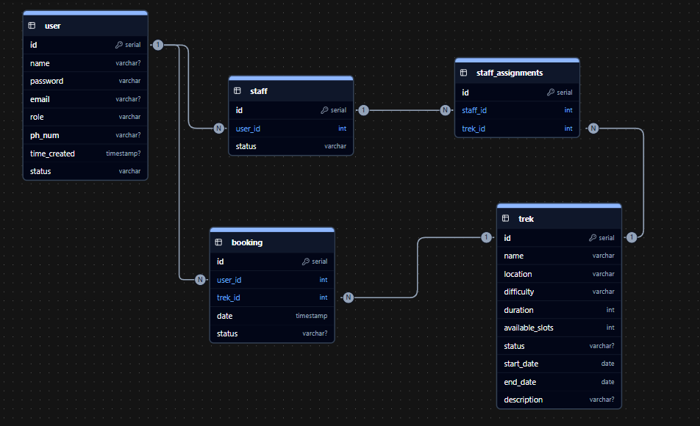

8. Video Presentation
Drive Link:
https://drive.google.com/file/d/1x7o6CVimM1R-OdHdgHJ_eA84xopdZVDt/view?usp=sharing

